CC Chair mission report

Subject and expected results | SAPOA POSTAL FORUM / 13th ANNUAL CONFERENCE  “Unlocking the Potential of Postal and Logistics: Driving Economic Growth and Development”  The Southern African Postal Operators Association (SAPOA) has been supported by UPU CC members and Wider Postal Sector Players: Reason Solutions; BoxC; Avalara; FarEye and HypaShip; Software Group.  OFFICIAL OPENING CEREMONY  In his opening speech, the Chairman of SAPOA, Mr. Maxwell Chitendeni stated that a new architecture of interconnectivity across Africa has to be created, as engine for action. It is true that the “Postal landscape is re-written currently” and the southern Africa is holding up the flag.  SAPOA has become a power focusing on 3 Pillars:  - Harmonization – standards should ensure a seamless interconnectivity  - Digital integration – T&T will ensure measurable quality  - Capacity building  Southern Africa is moving as one bloc. Therefore, governments have to align with the postal services with the strategic development plan becoming a critical infrastructure for the Pan-African Free Trade Area.  Digital transformation must not lead to exclusion, but to a level playing field. Postal volume is driven by diversification. Ecommerce requires new logistics. Financial services will adopt fintech, as physical branches stay important for financial inclusion as postal offices are going digital.  Conclusion: The 13th SAPOA annual conference will not be a talk shop. SAPOA will accept the challenge, showing that Southern African Posts are not by-standers, but the drivers of the digitalization.  Dept. Minister of Communication and digital Transformation of ZA put “Partnership” in the middle of his opening remarks. Decision makers should follow Canada’s premier’s example as stated at the WEF meeting earlier this year where trusted partners shall work closer together in a changing world.  “When S-Africa is prosperous, the whole continent is prosperous, therefore the postal network is an asset – not a liability. For S-Afrika the current effort to stabilize its DO and the pending reform is of highest importance - without stability no growth.  Digitalization requires a “hybrid and digital” approach, ensuring the integration of logistics platforms and their technological integration.  Trade corridors will require the alignment of customs so that ecommerce platforms can build their business onto a seamless logistic chain  The Post is not dying, but it will rise when modernized correctly. Still today the Post is the country’s most trusted entity.  The task at hand is unlocking potential. Transformation is not comfortable and success innovation needs leadership driving the way forward.  Logistics is the bloodstream of trade and societies. Postal Offices are not the back-office services, but front services in innovation and partnership  In his address to SAPOA, Dr. CS Moyo, SG PAPU pointed out that Partnership with private sector is important. Their presence is a clear sign and more engagement is better than less. Therefore 13th SAPOA meeting will be a success as well.  Technology Day: First round of Wider Postal Sector Player Presentations  The WPSP present also had their booth, well attended by the SAPOA attendees  - Presentation by FarEye (UPU CC member)*  - Presentation by Software Group (not a UPU CC member)  NOTE: Software Group is a software provider and service facilitator for financial services. Both, their Team Lead in Africa, Ms Jiva Kimani (Kenia), as well as their CEO Mr Kalin Radev asked for the official application package to become a UPU CC member  - Presentation by Reason Solution (UPU CC member)*  - Presentation by BoxC (UPU CC member)  - Presentation of Avalara (UPU CC member)  - Presentation By HypaShip (not a UPU CC member)*  NOTE: HypaShip is a software provider and service facilitator for onboarding various different commercial parcel, express or courier delivery operators. Their CEO Mr Neil Gold asked for the official application package to become a UPU CC member  *: signed a legally non-binging MoU with SAPOA.  Tactical & Strategy Day (1 & 2)  SA Post Office (SOC) Limited / Reengineering South Africa’s DO by Mr. Jikesh Jagbeer  SOC has developed a corporate strategy 2026 – 2029:  Situation analysis:  - The SOC Ltd Amendment Act, 2024 has expended SAPO’s mandate  - Postal Market is evolving: i) letters are declining; ii) parcel deliveries are increasing  - Inclusion must be delivered at scale  - SAPO’s financial sustainability requires a strategic pivot in its core business  - Trust, Accountability and effective governance ate non-negotiables  Strategic Pivot:  Transforming from a traditional postal model to an integrated service provider to enable holistic inclusion.  Strategic outcome:  The Postal Ecosystem transforms the SAPO into a strategic government infrastructure asset that is financially stable, operationally efficient, and fit-for-purpose, capable of fulfilling its social and commercial mandates while attracting investment and establishing beneficial partnerships.  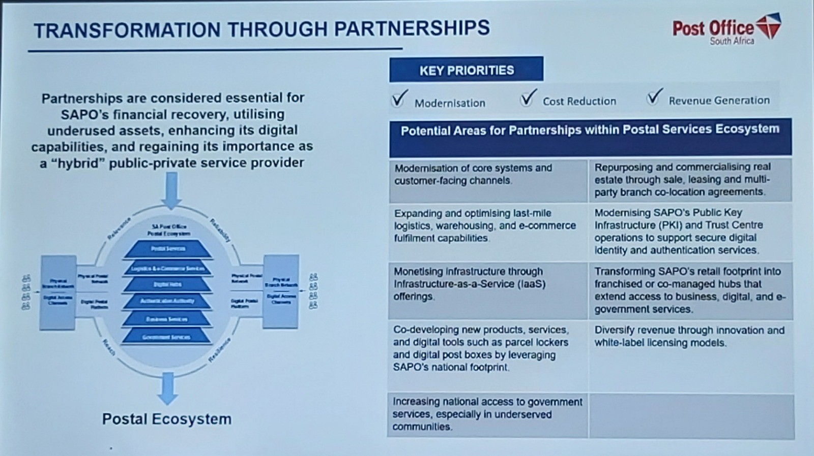  Business capabilities program objectives:  - IT Capital Expenditure (digital backbone, HW and System integration) -> linked to “digital / financial & MVNO”; “Trust Centre & Digital ID”; “Connectivity Enablement”;  - Mail Processing & Hybrid Mail (automated sorting & secure digital output) -> linked to “logistics & courier modernization”;  - Logistics Fleet Renewal (mid-mile haulage & last mile delivery vehicles) -> linked to “logistics & courier modernization” and “Trust Centre & Digital ID”;  - Building infrastructure upgrades (hub restoration & network rationalization) -> linked to “property & real estate modernization”;  - Leasehold improvements (multi-purpose branch & retail modernization) -> linked to “property & real estate modernization”.  Cash-flow continuity: Austerity measures are necessary to preserve cash and keep SAPO operating, but they also constrain service recovery. SAPO will prioritise prudent cost management and allocate available budget to critical operational intervention.  Funding uncertainty for the turnaround: SAPO is pursuing alternative funding routes – “particular partnerships” – to launch digital services, optimize its logistics services, monetize underutilized property, and support priority operational fixes to protect service performance and revenue.  Reserved-area regulatory matters: SAPO will continue engagements with DCDT and the Regulator to resolve outstanding regulatory issues. SAPO will strengthen monitoring and evidence collection on potential encroachment and pursue remedies where required, supported by an internal enforcement capability. In parallel, Sapo will drive greater certainty on USO service standards, reporting requirements, and a transparent funding approach linked to verified service outcomes.  Zambia Post’s Transformation; by Ms L. Simakando, PMG ZamPost  The question is no longer whether posts should transform – but how fast. Posts shall build onto their core assets: i) nationwide physical infrastructure; ii) trusted public institutions; iii) last-mile access to citizens.  ZamPost engaged in offering 300 services via its network to all citizens – becoming the national access point “CITIZEN ONE” platform for all governmental, financial services, digital platforms and reliable logistics (enabling the integration of “UBER-like” courier services – rather engage with motorbike riders, then buying motorbikes themselves).  STARLINK: the government made internet connectivity available to ZamPost, as well as ICT equipment in most Post offices countrywide.  ZamPost entered into a diversification strategy:  - Logistics & Ecommerce enablement -> Modernizing parcel and courier services: This includes real-time tracking, digitized logistics management systems, enhanced EMS courier services and improved last mile delivery capabilities.  - Digital government services -> supporting citizen access to government services  - Digital transformation -> Modernizing postal infrastructure and systems: This includes digital literacy and assisted services, internet access in underserved communities.  - Financial & insurance inclusion -> Expanding access to payments and insurance: This includes micro-insurance, insurance premium payments, over-the-counter financial transactions and digital payment services.  Addressing has become a major cornerstone of the postal diversification strategy. ZamPost is now directly included in the deployment strategy of the government, ensuring smart logistics and real-time delivery.  How will the government support and shape the postal industry in South-Africa looking at the next 5 years; Dept. Communication & Digital Transformation of the Rep. of South-Africa  The Dept. is shareholder responsible for the Oversight over the 100% state owned South-African Post Office (SAPO), to ensure that the DO provides an affordable USO and related services in line with the policies and legislation.  The sector is regulated by Independent Communications Authority of South Africa (ICASA) in terms of licensing and monitoring compliance. ICASA regulates SAPO in terms of reserved price setting, delivery standards, customer case and overall compliance with their licence.  The overall regulatory and legislative framework is partly outdated and in need of revision.  The sector is divided into two segments i) reserved and ii) unreserved services – both outlined in Postal Services Act 1998.  The reserved services all SAPO to deliver these services to the entire country, even in areas that are not viable. As the reserved area includes Items up to 1 KG, there is much controversy, with most private operators against the legislation providing reserved services (and little consequences).  Enforcing compliance is a challenge, leading to many private operators encroaching in the reserved area.  The government has amended the acts with the SAPO Amendment Act in 2024, setting the strategic objectives for SAPO, these are:  - Improved governance: ensuring governance structures and accountability at executive level;  - Achieve Financial Sustainability: revenue growth across logistics and ecommerce, courier / parcel delivery, digital services, governmental and financial services. Reduce avoidable costs, and improve asset utilisation;  - Deliver consistent customer and stakeholder value: meet the USO and performance standards set by ICASA and international instruments such as the acts of the UPU, customs care improvements and growth in the market share;  - Build competitive capabilities: infrastructure modernisation to deliver efficiency and effectiveness, continuing of engagement of CAPEX funding as part of partnerships initiatives already commenced with.  Government is supporting the SAPO-funding by:  Securing the appropriate funding of the USO of SAPO. This includes the subsidising of Post Offices located in rural and disadvantages areas and communities – about 260 outlets of SAPO. The government understands that this funding is not sufficient, but SAPO will have to be required to develop cost accounting to determine the actual cost for delivering the USA.  The Dept acknowledges the need for a capital investment modernise the Post Office infrastructure as part of the turnaround strategy. This is part of an ongoing discussion towards a SAPO business rescue exit.  The impact of Ecommerce on Postal and Logistics services – Opportunities and Challenges; by GeoPost / La Poste, Mr B. Morel (UPU CC member)  Enhancing Supply Chain Efficiency through Postal and Logistics Services – DHL Express, Mr A. Betuidenhout (member of GEA - / UPU CC member)  Digital Trade and Cross-border Ecommerce – Opportunities and challenges in facilitating digital trade and cross-border ecommerce; Ecomafrica, Mr A. Tempest  The USA application of heavy tariffs has forced companies to look for new markets. While the obvious targets are Europe, China and India, these markets are challenging.  More welcoming are markets such as middle east – however currently a war zone – S-America, Canada, Australasia.  Looking at Africa, the challenge is the completion of the African Free Trade Area (AfCTA).  When looking at the current Ecommerce landscape it is safe to state: Key players are dominating, increasingly a common operating model is emerging, still frequent compliance gaps and fiscal governance create risks and frictions for cross-border operations.  Regulation is tightening: this is driven by revenue loss from online imports, better data sharing via digital customs systems, pressure to equalize retail competition and even growing cross-border parcel volumes of low-value consignments.  For many domestic ecommerce markets small value parcels are “collateral damage”.  Since COVID, many markets have experienced the invasion of “ultra-fast-fashion” (UFF) from the P. R. China. UFF Has used the de-minimis customs system and other concessions to flood markets at minimal customs duties and often without having t pay VAT / sales tax.  The response to this has been that governments are removing the de-minimis customs benefit, as well as tightening other regulations (i.e. introducing taxes for environmentally damaging goods)  African B2C sales to the USA, Europe and some other countries have dropped markedly. This is a serious challenge for African SMEs selling artisanal goods.  For Africans it is key to watch cross-border regulatory areas:  - Import duties and customs valuations rules are impacting landed costs and pricing;  - Product safety, labelling standards compliance for each destination market;  - To reduce regulatory risk, the objective is to prioritize tax, customs, safety and platform policies (as they become deemed seller, or deemed importer);  - VAT and GST requires cross-border sellers to comply to registration and collection obligations;  - Compliance to platform liability and seller due diligence obligations is paramount for any listing and transaction.  Opportunity for Postal Operators to become a vital driver for cross-border growth  - Expanding SME market access: Postal operators enable SMEs and micro exporters to reach global markets through affordable shipping;  - Developing integrated logistics: Postal operators provide end-to-end interoperable logistics and last-mile connectivity;  - Enabling cross—border ecommerce: Postal operators facilitate online trade through customs support, tracking and returns;  - Defining digital trade facilitation: Operators adapt digital tools to improve data exchange, compliance and delivery speed;  - Advancing inclusive export growth: Postal services play a direct role in connecting underserved regions to global trade.  Ecommerce and Logistics Infrastructure Development – Investing in infrastructure to support ecommerce growth; UPU CC presentation, Mr W. Trezek  Investing today to enhance service tomorrow in Seychelles – nurturing new talent and ideas; Seychelles Post, Ms Mariella Buisson  For Seychelles Post it has been essential to create a sustainable and inclusive work place, by creating an atmosphere a PRIDE.  Pride is not just emotional – for Seychelles Post it is strategic. It attracts talent by making the organisation a place people want to belong to, an it develops ideas by giving them the confidence and purpose to innovate.  When people feel proud of their organisation, their work and their legacy, they naturally become ambassadors who attract new talent and inspire innovation.  Investment in talent is not a cost – it is a long-term investment on better service.  Skilled teams streamline processes and elevate service delivery.  Empowered teams adapt to demands and changes faster.  They then contribute beyond the workplace, strengthening communities and inspiring others.  The best way to predict the future is to create it:  - Invest in training, innovation and collaboration  - Empower teams to deliver smarter services  - Deliver excellence for customers, partners and communities

Signature: Mr Walter Trezek (UPU CC Chairman)

